**Project name : Shopping Centre Management System**

**Abstract:**

In this project, we will be designing a simple shopping center management system . The software will provide a soothing shopping experience for users, while at the same time allowing us to explore design patterns and other features. The objective of the software is to login and get information about product and sales details. The system stores all the information about the product and their complete details. The Shopping Centre Management System application enables vendors to set up shops, and a system administrator to approve and reject requests for new shops and maintain lists of shop categories. Also on the agenda is designing a shopping manage the items in the shop and also help users to sale them . Shopping will be highly personalized and the mall will provide lower prices than most competitors. This, in brief, is a description of our product which will showcase a complete shopping experience in a small package.

**Introduction:**

Every organization whether big or small has human resource challenges to overcome; therefore we designed an exclusive shopping center management system which is adapted to the managerial requirements. This is designed to assist in strategic planning and will help one to ensure that the organization is equipped with the right level of human resources for future goal.

Shopping center management system is a store that enables owners to sell their product. It is a shopping center that enables the day-day sales functions. The system helps the customer to purchase the products . It includes sophisticated product and customer management modules. This software will be useful to admin panel and user of a shopping center. It generates the reports related to the system.

Shopping Centre management system is a very important feature used in shopping mall to assist customer making purchases any products. This project deals with developing software for different types of products. It provides the user with a catalog of different types of products available for purchase in the store. In order to facilitate purchase a shopping center management system is provided to the user. The project has been developed to allow business grows larger and faster. This will let users to view and order products from any part of the shopping center. Under this software many products and services can be ordered.

The Shopping Centre management system is expanded permanently through new products and services in order to offer a product portfolio corresponding to the market. Private customer and business customers can order the selected products of the service quickly and comfortably

**Propose method :**

In this project, we will be designing a simple shopping mall management system. The mall will provide a soothing shopping experience for customers, provide mall management functions to mall administrators and inventory/staff management to shop owners at the mall. When one will open this software there will be openned a login page where only user and admin panel can access here with their user id and password with type.

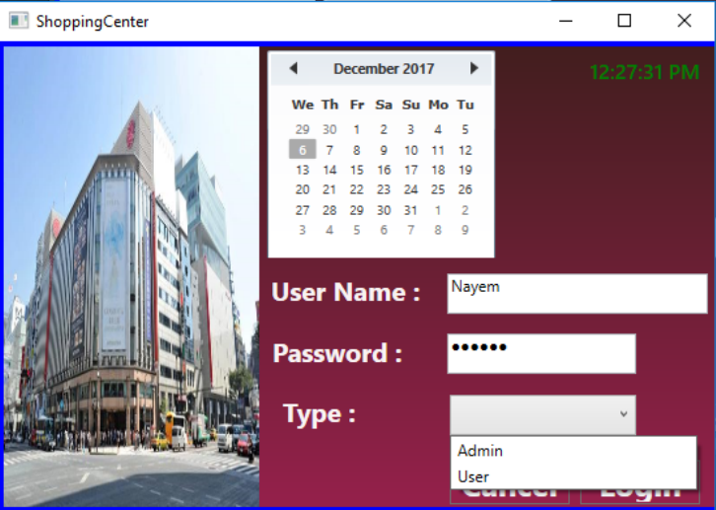

Fig: Login

**Admin:** If the user type is admin then there will be opened a window where sale, view sale, product, calculator, account and logout options are included. The Admin is the super user and has complete control over all the activities that can be performed. The application notifies the admin of all shop creation requests, and the admin can then approve or reject them. The admin can check the whole system to see all the shops in the mall.

* In the sale section product details can be shown by searching by the product id. With the information of product details such as product name, category, price in the “sale table” a product can be sold. If any product is sold then it will be shown in the “show sale list table”.

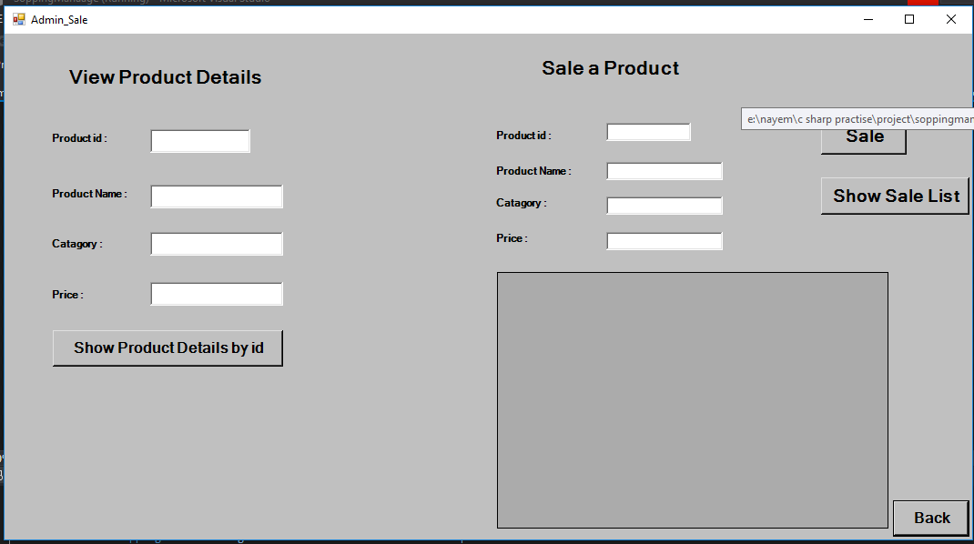

Fig: Sale Table

* In the product section available products can be shown. The stock is shown in the product section with the product details. Here new product can be added into the stock or old product can be deleted from the stock. Here product details can be edited too.

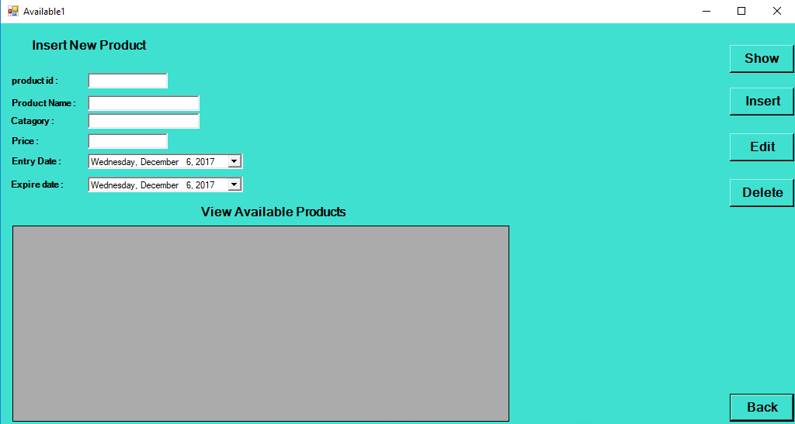

Fig: Available Product

* Only admin can access the account section. Here buy item, cost, employee, loss/profit, product and go back to homepage options are included. In the buy item section daily buy, weekly buy, monthly buy and yearly buy is included. In the cost section total employee cost , total product cost,others costs like rent travel etc is shown. Here new cost also can be added in the add cost section. In the loss/ profit section loss or profit can be shown of any product.

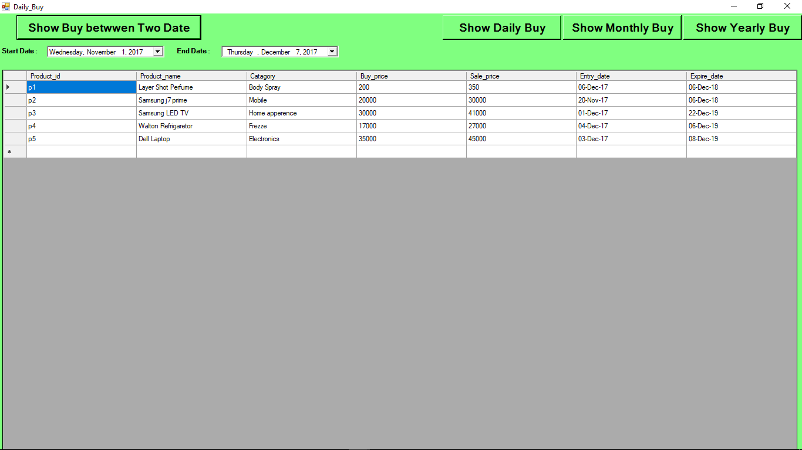

Fig: Buy table

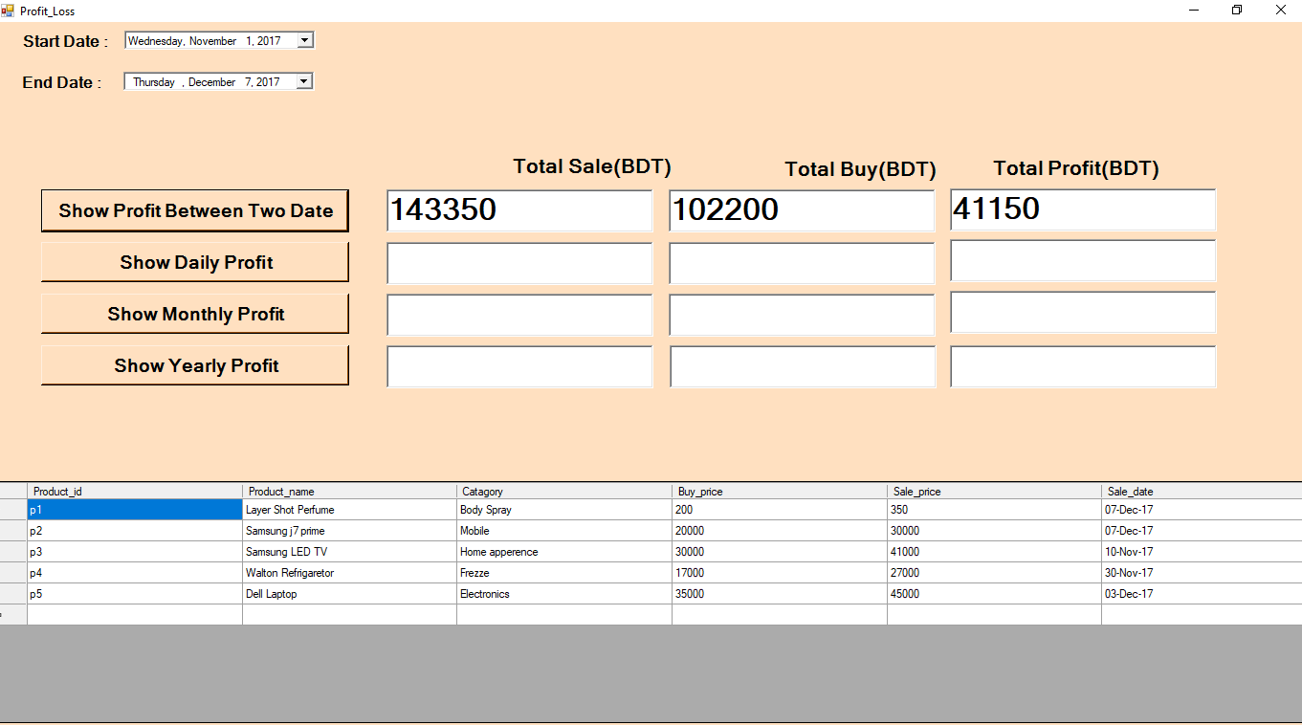

Fig: Profit/Loss

* Various personnel include the mall administrator. The mall administrator gets to access the database for information regarding the mall employees. The administrator has access to the entire plan of the mall to see the present status of each shop and access information regarding the same. This can be done by clicking on any desirable shop on the entire planand selecting the kind of information that he requires to see.
* The administrator also has the facility to see the sales and revenue status of the mall. The shop admin has the functionality of accessing the inventory status of his/her shop and make changes to it accordingly. He/she can also access the employee details of the people who work in their shop and edit them whenever required or even remove them, thus revoking their rights to the shop. . In the employee section a new employee can be added, deleted or shown an employee with his employee id, name, qualification, address, post, joining date and salary with image.

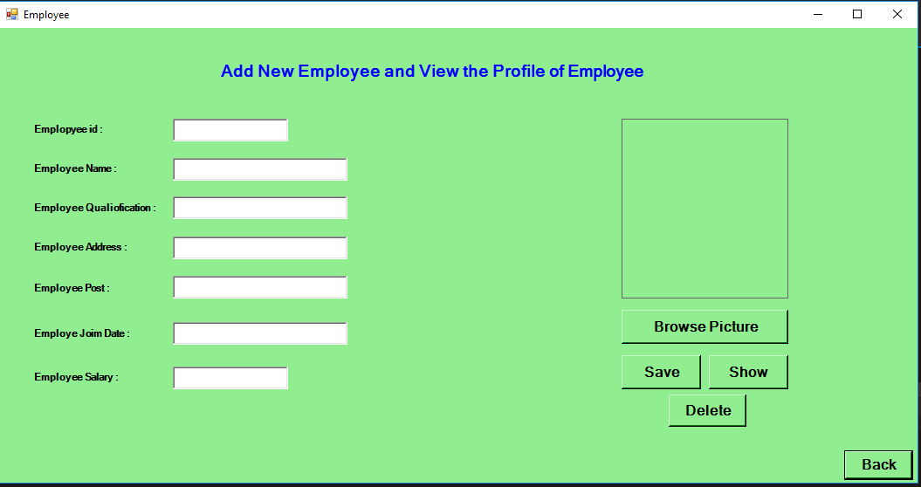

Fig: Employee

* The shop admin gets to see the information regarding the sales of the shop from the previous times and the predicted sales as well. The mall administrator and the shop owner have some common and overlapping functionality as well which includes access to the events functionality and the lease management. Events show the present and future events that are lined up in the mall for the purpose of publicity, entertainment for customers and revenue generation.
* New events can be added according to the availability on that particular day and the events lined up can be seen. Lease management allows the shop owners to check the end date on their lease of their respective shop and also apply for the extension of the same. The same can either be granted or denied by mall administrator accordingly. The mall administrator can access the lease information for all the stores in the mall.

**User :** Any user can submit a request through user id, password and user type. When the request is approved the requester is notified, and from there on is given the role of the user. The user is responsible for setting up the shop and maintaining it. The job involves managing the inventory in the shop. Also, the user can add or remove items from shop. The user can access all the section the admin panel can access without the account section.

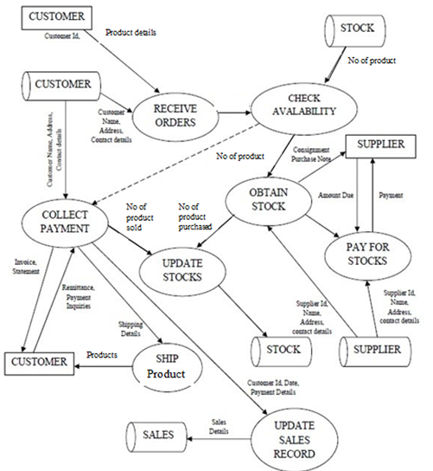

.

Products

Products

Figure : System Representation(DFD)

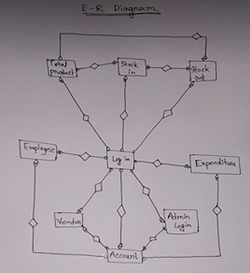

Figure : System Representation(ERD)

The diagram represents the methodology in which the system will provide functionality to the respective clients who use the system. The system depicts the software to provide an integrated solution for the mall personnel to access various types of information through the database and make changes to it wherever necessary.

**Existing method:**

Generally, it must be remembered that the shopping Centre industry has moved fast since the early 1950s, as mentioned earlier. In fact, in the past 58 years of growth, shopping centers have created important roles and challenges for shopping Centre management.

Since the nineteenth century, one of the most consistent challenges in shopping Centre management has been to identify, understand and meet the ongoing needs of consumers, retailers and owners. These key parties are fundamental to any shopping Centre in the world. It is important for the owner/developer to establish excellent management teams in order to face the challenges.

Though we have completed our project shopping centre management system but we have a future plan towards this project. Those we couldn’t add to this project we will try to add in future. In the view sale we will add daily sale, weekly sale, monthly sale and yearly sale. We have plan to add risk item, damage item where the product which will be date expired that will be marked. So we can remove those products from stock.

We have plan to add credit card system so the customers can pay with their credit cards and buy products with their credit cards. If we could add these factors in our project we could improve the project more and more.

**Result analysis:**

The organization requires computerizing the shop to fully automate its corresponding activities. The requirements from the proposed software are as follows. It will keep and manage product detail. It will prepare price details. By this customer will be managed and billing will be processed. It will maintain salary details of every employee. We should remind that the system will be secured enough to rely upon. Users will not be allowed to delete or modify any records. Users will not be allowed to take a financial reports. Every users report keeps the tracks of user inputing the records.

The future operation and management of shopping center system can be used with multi-function navigation system the build, to increase the stores within the building to increase the stores within the operating income and to expand customer service levels. Future Store Trading Information Management System can be expanded with multi-function navigation system the build, in order to increase sales within the operating income , to expand customer service levels and provide personalized shopping mall marketing.

**Use of resources :**

* User interfaces: It has been required that every form’s of interfaces were user friendly and simple to use. Besides, there was facility of accessing the system through laptop, keyboard along with the mouse.
* Software interfaces: It has been required that there was a necessity of using the stored data for some kind of report that is not supported by proposed system at present.The software we needed was visual studio using c-sharp language and the sql server was needed data storing server.

**CONCLUSION :**

Shopping centers are unique as a real estate format because they typically evolve more rapidly than other properties. They serve many different people, in addition to consumers, retailers and owners. Traditionally, major retail shopping centers have been managed by different in-house management teams, in a traditional fashion. Many are managed on behalf of investors through a combination of center management teams and managing agents. They generally provide the primary focal point for managing the building asset and retaining relationships within the community and with retailers, with substantive support from consultants and contractors on a center-by-center basis. As a result of all this, a confusing range of relationships exist, ranging from retailers' service contracts to center IT infrastructure, promotions, mechanical, electrical and fabric maintenance, cleaning, lifts and security, and a host of other arrangements. With the suggested solution, the mall can be managed by mall administrators in a more centralized fashion rather than distributed functioning of different departments. It also allows the store owners at the mall to manage their stores using the system. It allows them to manage the shop’s inventory, its employees and other critical functions. The proposed system is an online system and hence mall administrators and shop owners can work from remote locations. The system is available at any time of the day and does not require the administrators and shop owners to be present at the mall. It provides an integrated solution to managing the mall than the use of a number of individual solutions.